**DAILY ONLINE ACTIVITIES SUMMARY**

|  |  |  |  |  |  |  |  |  |
| --- | --- | --- | --- | --- | --- | --- | --- | --- |
| **Date:** | 21-05-2020 | | | | | **Name:** | SINDHU N | |
| **Sem & Sec** | 6th and B | | | | | **USN:** | 4AL17CS094 | |
| **Online Test Summary** | | | | | | | | |
| **Subject** | | OS (1ST IA TEST) | | | | | | |
| **Max. Marks** | | 30 | | **Score** | | | 29 | |
| **Certification Course Summary** | | | | | | | | |
| **Course** | CLOUD COMPUTING | | | | | | | |
| **Certificate Provider** | | | Greatlearning academy | | **Duration** | | | 1 WEEK |
| **Coding Challenges** | | | | | | | | |
| **Problem Statement:** GIVEN 2 PROBLEMS | | | | | | | | |
| **Status:** Completed | | | | | | | | |
| **Uploaded the report in Github** | | | | | Yes | | | |
| **If yes Repository name** | | | | | https://github.com/lsindhungowda/Daily-report | | | |
| **Uploaded the report in slack** | | | | | Sindhu N  Yes, I uploaded the report in slack | | | |

**SNAPSHOT OF FIRST IA TEST MARKS:**

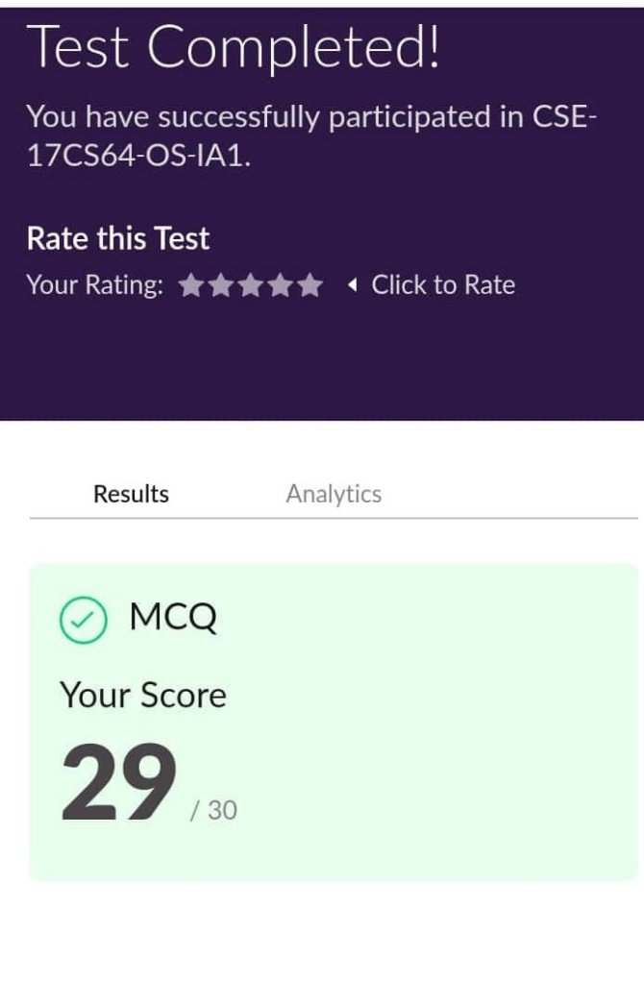

**SNAPSHOT OF ONLINE CERTIFICATION COURSE:**

**SCREENSHOT1:**

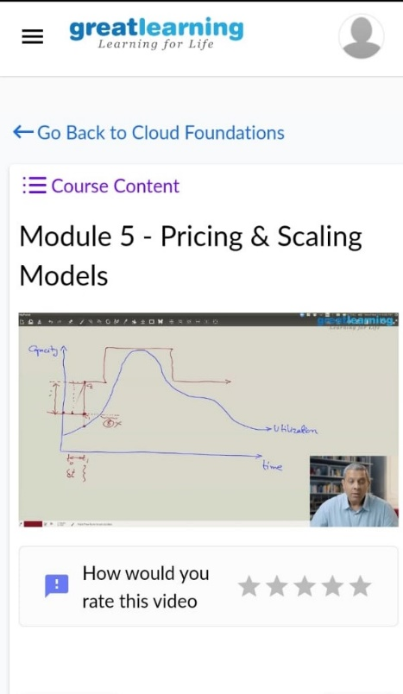

**SCREENSHOT2:**

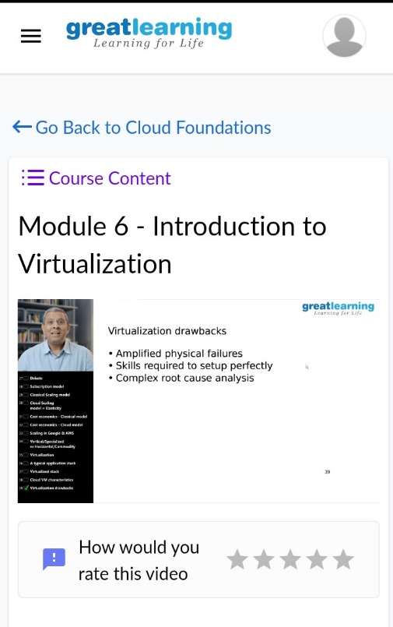

**SNAPSHOT OF ONLINE CODING:**

PROGRAM 1:

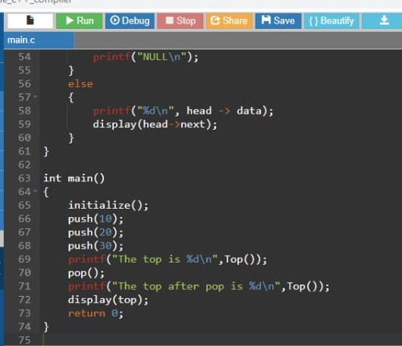

**OUTPUT:**

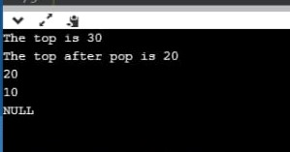

PROGRAM 2:

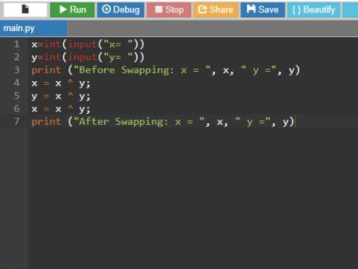

**OUTPUT:**

